Dear Parents/Carers
Following our last letter regarding County Lines which we sent in May we wanted to get back in touch to remind you that you can still help.

County Lines is the term used to describe the networks of gangs and organised criminals who export illegal drugs into other areas of the country, often smaller areas, using dedicated mobile phone lines known as ‘deal lines.’

They exploit children and vulnerable people to move and store drugs and money. Often, they do this using blackmail, intimidation and violence.

Staffordshire Police are working alongside our partners as part of a County Lines operation which has two aims – to arrest members of organised crime gangs who target young and vulnerable people, but also to identify young people who are at risk of criminality and to help divert them away from criminal exploitation.

We are asking education establishments and parents to help identify young people who are at risk of criminality, so they can be given help.

There are several signs to look out for that may indicate someone is involved in county lines:

- repeatedly going missing from school or home and being found in other areas
- having money, new clothes or electronic devices and they can't explain how they paid for them
- getting high numbers of texts or phone calls, being secretive about who they're speaking to
- decline in school or work performance
- significant changes in emotional or physical well-being

We have produced a podcast which discusses the issue of County Lines and how support networks including parents and carers can help to protect children from exploitation. To listen to the podcast (episode 6) visit: https://thebeatpodcast.buzzsprout.com/

No one school in Staffordshire is more or less affected by these problems. We know that the overwhelming majority of young people will never be affected by this issue but a conversation with your child will help us collectively make a difference. It is critical that young people know that there is help available if they are involved in County Lines activity and that they can get support from home, school and agencies who work with young people

You can find more information in the enclosed leaflet and on our website here: https://www.staffordshire.police.uk/countylines

Thank you for your support in this matter.

Best wishes,

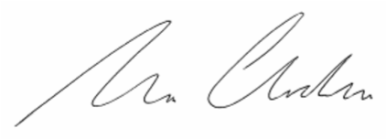

Detective Superintendent Tom Chisholm
Head of Major & Organised Crime, Staffordshire Police

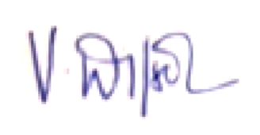
Victoria Wilson
Cabinet Member for Communities & Culture

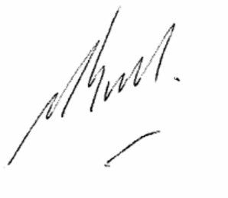
Mark Sutton
Cabinet Member for Children & Young People

