Two Gates Primary School Assessment Statement

Our Approach to Assessment:
At Two Gates Primary School, we believe:

- Assessment is an integral part of quality first teaching. It helps us to identify learner’s strengths and next steps in their learning.
- Assessment should support every child in making at least expected progress.
- For assessment to be robust, staff must have training as well as time to discuss progress and moderate judgements on a regular basis.
- Assessment should support Leaders in identifying issues within school and should improve teaching and learning across school over time.

Our Method for Assessment:

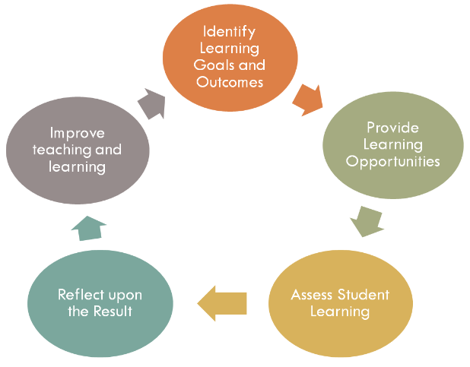

The most important use of assessment is to help staff, pupils and parents plan learners’ next steps in their learning. Assessment also informs the reporting of pupil outcomes and school performance.

The flow chart on page one talks about the cycle of assessment at Two Gates. This cycle is repeated on a termly basis.

Formative and Summative Assessment:

In order for teachers to gain a range of evidence, they use a variety of formative and summative assessment strategies.

Formative assessment is key to our understanding of a pupil’s abilities as it is based upon a complete picture of a learner. Formative assessment is about assessment for learning; this is collated from a child’s performance in class, both verbal and written, in a range of subjects. The important thing is that it gives feedback to pupils in the moment so that they can move forward in their learning. This feedback is provided verbally from teachers and teaching assistants, marking in books as well as one to one and group discussions, where staff will work with pupils to discuss their progress and their next steps. A teacher’s assessment of a pupil is largely based upon this formative assessment as it produces a rounded and full picture of a pupil’s performance. It should be mentioned that formative assessment is also supported by key assessment foci based upon the National Curriculum 2014, a statutory document.

Summative Assessments are given at key times within a year to determine at a particular point in time what students know and do not know. These include such things as reading and spelling tests from year group words, (in KS1 this is our Read, Write Inc reading assessments and in KS2 we follow the Read, Write, Inc spelling scheme) as well as formal tests. Standardised tests, currently NFER, help to demonstrate to a teacher if a child understands a subject, but staff are very conscious that they are only a snapshot of understanding, taken at a moment in time. Staff are also aware that some children respond well in test situations whilst others do not; other factors, such as illness or upset, may affect how a child performs and therefore these types of assessments are planned for carefully. For example, an assessment may be delivered in a small group rather than in a large class situation, or a child may need a reader to help them understand a task or question. Summative assessment serves to support a staff’s formative assessment; it is only a small part of the bigger picture.

How do we ensure our judgements are accurate?

All of our criteria is based on our School Curriculum which is based on the National Guidelines from the Department for Education in the National Curriculum for Primary Schools documents (2013/14).

The data collected is kept securely on an online data system (currently ‘ATLP Academy Trust Tracker) in which we track whether a child is ‘pre-key stage, working towards, expected or greater depth’ a concept within a subject.

Further moderation and discussion of judgements takes place within school where staff meet together and discuss their judgements and the next steps in learning for groups of children. We moderate pupils work using assessment foci and exemplification materials. We also moderate externally with the Arthur Terry Learning Partnership and our other local schools.

How do we use our Assessment data?
- Staff use data to summarise the progress and attainment of pupils in their class and identify their next steps in learning.
- Staff use the ATLP Academy Trust tracker to help them plan effectively for the range of abilities in their class.
- To ensure every pupil makes at least expected progress, staff meet with leaders on a termly basis for a pupil progress meeting. Here, teachers meet with a member of the Leadership Team to discuss successful interventions and teaching strategies as well as discussing vulnerable pupils who might be at risk of not making expected progress. This also ensures stretch and challenge for all.
- The information on assessment is shared with parents and pupils through conversations and written reports.
- We are required to submit data to the local authority and the Department for Education at key points (below). Parents can view our outcomes on our website:

- Reception (End of EYFS data)
- End of Y1 (Phonics Screening data)
- End of Year 2 (KS1 Results)
- End of Year 6 (KS2 Results)

If there is anything else you would like to discuss, please contact your child’s class teacher or contact a member of the Senior Leadership Team via the school office.

