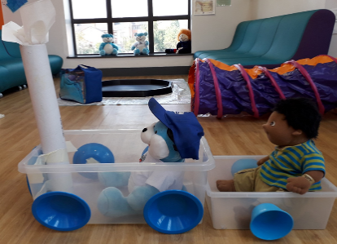

**To register your interest in a course, please email: groupwork@staffordshire.gov.uk with the following information:**

**For parents and carers:** please send your name, child’s name and date of birth together with your contact number, and which course and day you are interested in attending.

**For professionals:** please complete the group work referral form and send to the above email.

A member of the group work team will contact you as soon as possible to discuss available places.

A member go

**g Debbie Fogg on: 01283 233400.**

**Simply Play for 0-4yrs (PEEP)**

**10 weekly sessions**

A virtual course for families with a child/ ren age 0-4 years

Fun activities and learning to

support your child's development. Different themes every week, with stories, songs/ rhymes to join in.

Learn how to support your child's early years and gain new skills and knowledge.

FREE Virtual courses delivered by Families First

**Open to all families living in Staffordshire**

**August to December 2020.**

We are offering a limited number of FREE Community Learning Service funded courses delivered virtually to families across Staffordshire in the Autumn term. Programmes will be run by highly experienced tutors who all have many years of experience in supporting families, and helping adults and children to learn

together.

Virtual courses consist of different themed sessions each week, with tutor feedback provided to ensure that family’s needs are met. Delivered on a 1-1/ small group basis using WhatsApp, phone calls and email with video demonstrations, access to online materials and a weekly activity to complete at home. Start dates available in August and September. **Virtual courses are open to any adult age 19yrs+**

.

**Simply Play for Babies (PEEP)**

**10 weekly sessions**

A virtual course for families with a baby up to 12 months.

Enjoy new sensory play ideas, early language activities and get lots of ideas to try at home, while developing your understanding of how you can support your baby to grow and develop.



*You must be able to commit to a minimum of 8 sessions in order to enrol onto the 10 session courses*



**Staffordshire Bump to Baby antenatal programme**

**(6 sessions)** for both mum and dad to be, is still being offered virtually by every

Early Help Team.

**Parenting Teenager’s course,** **(6 sessions)** designed to help parents with strategies and confidence to parent children age 11yrs+ is still being offered virtually by every Early Help Team. **Please contact the Early Help Team direct.**

**‘From Pram to Primary School’**

**10 weekly sessions**

**A virtual course to help you support your**

**children’s behaviour by Family Caring Trust.**

**Struggling with your child’s behaviour; mealtimes and bedtimes becoming a challenge?**

If your child is aged between 0-11 years, then this programme could be for you.

.