Two Gates Teaching and Learning Policy: 2020-2021

Statement of intent
Every child has the right to the best possible education. We aim to ensure that all pupils, regardless of ability, SEND or circumstances, reach their full potential and gain the skills and knowledge necessary to lead successful lives.
This policy provides procedures aimed towards ensuring high quality teaching and learning throughout the school.
It aims to:
- Embed an agreed range of good practice across the school.
- Ensure consistency throughout the school.
- Inform staff of the school’s expectations.
- Provide a unified focus for monitoring learning and classroom practice.
- Ensure that the needs of pupils are met.
- Improve and enhance the quality of teaching.
- Ensure that pupils are receiving a broad, balanced and relevant curriculum, meeting the requirements of the national curriculum.
- Ensure that teaching is appropriately differentiated for all pupils.
- Establish targets for improvement.
- Enhance the professional development of staff.

Legal Framework

This policy has due regard to all relevant legislation and statutory guidance including, but not limited to, the following:
- Equality Act 2010
- DfE (2018) ‘Primary school accountability in 2018’
- DfE (2015) ‘Special educational needs and disability code of practice: 0 to 25 years’
- STA (2018) ‘Early years foundation stage: Assessment and Reporting Arrangements (ARA)’
- STA (2018) ‘Key stage 1: Assessment and Reporting Arrangements (ARA)’
- STA (2018) ‘Key stage 2: Assessment and Reporting Arrangements (ARA)’
- DfE (2017) ‘Statutory framework for the early years foundation stage’
- DfE (2019) ‘Assessment framework: Reception Baseline Assessment’
- DfE (2018) ‘Reporting to parents at the end of key stages 1 and 2’.

Links to other policies:
- SEND Policy
- Marking and Feedback Policy
- Behaviour Policy

Our Philosophy:
Much research and focus has been undertaken by the school to understand how children learn best. This has resulted in a refined understanding of what conditions are needed for great learning. All the strategies which have been adapted are rooted in evidence based research.

Learning is at least in part defined as a change in long-term memory. As Sweller et al (2011) has pointed out, ‘if nothing in the long-term memory has been altered, nothing has been learned’. It is, therefore, important that we use approaches in our classrooms which help pupils to integrate new knowledge into the long-term memory and make enduring connections that foster understanding.

To do this we can draw on a growing evidence base from the ‘learning sciences’. Learning sciences is a relatively new interdisciplinary field that seeks to apply understanding generated by cognitive science to classroom practice. This includes the work of John Hattie, John Sweller, Oliver Caviglioli and Barak Rosenshine.
As a result of this, the intent of our curriculum has been constructed using 5 key pillars:

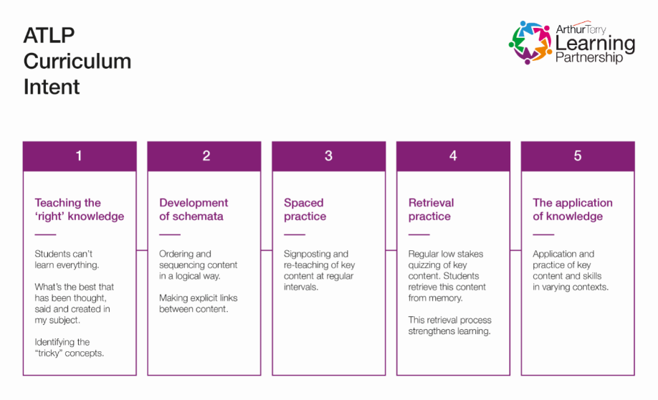

1: Teaching the right knowledge

Pupils can’t learn everything. Cognitive science suggests that students should learn the concepts that come up again and again. (Willingham, 2008). As a school and a MAT, we have focused on identifying the key knowledge pupils need to know by key milestones.

2: Development of Schemata

An important contribution to learning science is made by cognitive load theory (CLT). CLT is concerned with the structure of memory and the brain, and in particular the capacity of the short-term memory to process information. The long-term memory consists of a range of schemata, which are complex structures that link knowledge and create meaning and which are built up over time. Learning is essentially about changing those schemata, through acquiring knowledge and making connections with different schemata. However, before entering long-term memory and developing schemata, information must first be processed by the short-term or working memory. As this has limited capacity, retention of knowledge and development of schemata will not happen if the working memory is overloaded (Kirschner et al, 2006).
3: Spaced / Distributed Practice

Teachers need to use spaced or distributed practice, where knowledge is rehearsed for short periods over a longer period of time, to study a concept closely for a longer period of time. We recognise it is good practice to block learning and repeat practice over time, as this leads to better long-term retention of knowledge (Rohrer & Taylor, 2006; Rawson & Kintsch, 2005).

An important element of securing deep learning is the revisiting of key concepts and adding new information which links and connects to prior schemata. Our Curriculum has been built carefully to ensure this can happen.

The most beneficial time of remembering something, is just before you forget it. Spaced retrieval is a key technique used by our teachers to ensure retrieval of prior content is crucial.

4: Retrieval Practice

Another important practice for effective retention of knowledge in the long-term memory is retrieval practice. The act of retrieving previously introduced knowledge builds long term memory. Every time, students are asked to recall something learned in the past, the memory of this piece of knowledge is strengthened and its durability is extended. (Mccrea, 2017). Retrieval is far more effective than more frequently used strategies such as re-reading as it strengthens memory and makes it easier to retrieve the information later (Barenberg Roeder & Dutke, 2018; Roediger & Karpicke, 2006).

Retrieval practice needs to occur a reasonable time after the topic has been initially taught and needs ideally to take the form of testing knowledge, either by the teacher for example questioning using flash cards, a test or getting pupils to write a concept map or through pupil self-testing. We regularly use these techniques to support our learning.

5: The application of knowledge

Peps McCrea discusses ‘Enduring understanding’. In order for pupils to build strong sustainable structures within their long term memory, pupils need to have a deep understanding of knowledge. This can only be achieved through the application of knowledge.

As well as identifying key knowledge within our curriculum, we have also identified key skills which will be developed and used to apply across the curriculum. This ensures our pupils are regularly applying what they have learnt in a deep and meaningful way.

What will this look like in the classroom?
Teachers will use strategies which they feel best suits the needs of the learners in their class and the activity they are undertaking.
The range of strategies are taken from our understanding of best practice and ‘what works.’ This supports the intent of our curriculum.
Below these are explained in detail. There is also a one-page poster (Appendix A) highlighting the different strategies which may be used.

Dual Coding:
In presenting material, teachers can make use of dual coding. Dual coding theory suggests that representing information both visually and verbally enhances learning and retrieval from memory. This means that, when recalling information, we can use either the word or the picture associated with it, thus increasing the likelihood that we will remember the concept, as using one representation does not mean we lose the opportunity to use the other.

Thinking Maps

Thinking maps provide an opportunity to visualise thinking. Each of the 8 Thinking Maps corresponds to one of eight different fundamental thinking processes. They provide a common visual structure to enable pupils to visualise and understand their thinking.

The 8 thinking maps are:

Circle Map - used for defining concepts
Bubble Map - used for describing concepts
Flow Map - used for sequencing and ordering events
Brace Map - used for identifying part/whole relationships
Tree Map - used for classifying or grouping
Double Bubble Map - used for comparing and contrasting
Multi-flow map - used for analysing causes and effects
Bridge map - used for illustrating analogies

Rosenshine’s Principles of Direct Instruction:

Barak Rosenshine’s principles of direct instruction infoms the way teachers plan and deliver their lessons. This ensures that pupils build strong understanding in their long term memory.

Daily Review | Daily review means pupils retrieving the knowledge they used in previous lessons. This also helps to support new learning which may be connected. We use knowledge organisers to support this.
Monthly Review | Monthly review should concentrate on retrieving previously learnt knowledge through low stakes testing and reviews.
Ask questions | Pupils are encouraged to ask questions, and with support find the answers to those questions. All learning within the curriculum is built upon key questions which supports this approach.
Check for student understanding | There is a key focus on teachers asking lots of questions which go deeper. Teachers should check pupils understanding through questioning. Questions such as ‘how did you get that answer?’ and ‘can you prove it?’ are a key feature of our provision.
Present new material using small steps | To make sure we don’t overload pupils, any new concepts should be presented in small, logical steps. For example planning a piece of writing or a multi-step maths problem.
Provide models | This is where teachers may use thinking maps to structure their own thinking. Worked examples (teachers showing how they do things) enables pupils to see what thinking needs to happen to complete an activity.
Provide scaffolds for difficult tasks | When pupils are completing a challenging tasks, teachers provide models or structures to break down the task. This again may include thinking maps. Over time, these scaffolds are removed so that the pupil can master the skill themselves.
Guide student practice | When pupils are learning something new, the teacher monitors the learning closely ensuring pupils don’t make too many mistakes. This makes sure they will be successful as the learning gets deeper.
Obtain a high success rate | In practice, to be successful pupils need to be successful 80% of the time. Teaching should allow time to practice to ensure pupils can gain this level of success.
Independent practice | Teachers make sure pupils have regular time to practice the knowledge and skills they have learnt by themselves. This secures the knowledge in the long term memory.

English Planning
In Writing, teachers create text medium term plans based upon a half termly text, using our predict, interrogate, capture, create planning model. These medium term plans include planning in oracy objectives for each week and the spellings that will be taught and applied within that unit of work. One medium term plan is created per text type. These are then carefully resourced with slides and differentiated work for the children each week. Planning is supported by our progression in different text types document and by year group writing objectives. Plans for writing run alongside the Guided Reading VIPERs approach in Years 2-6 to ensure reading impacts upon writing.
In reading, EYFS and KS1 use the daily Read, Write Inc phonics scheme of work to teach pupils to segment and blend. This scheme has been carefully adapted to meet the needs of our pupils and school. Once competent readers, in Year 2, fluency and comprehension is developed through our daily VIPERS approach. In VIPERS, teachers carefully select questions for children to answer based upon their half term’s whole class text. This text is rotated between fiction, non-fiction and poetry. They use their year group reading objectives to pitch their questions correctly and set questions based upon vocabulary, inference, prediction, explain and summarise (sequence in KS1). They use the question stems to support their planning of these questions and also include a range of question types such as matching, numbering and ticking to vary the approach. Whilst reading the text, teachers monitor the word reading skills of pupils and keep a record of outcomes. Each VIPERS session includes a taught or applied reading strategy to help pupils to access the text, for example; skimming, scanning, reading on and back (see reading strategy cards for full list).
Maths Planning
The content and principles underpinning the 2014 Mathematics curriculum and the Maths curriculum at Two Gates reflect those found in high-performing education systems internationally, particularly those of east and south-east Asian countries such as Singapore, Japan, South Korea and China. To ensure whole consistency and progression, the school uses the DfE approved ‘Power Maths scheme.
These principles and features characterise this approach and convey how our curriculum is implemented:
• Teachers reinforce an expectation that all children are capable of achieving high standards in Mathematics. The class is a learning team.
• The large majority of children progress through the curriculum content at the same pace.
- Differentiation is achieved by emphasising deep knowledge and through individual support and intervention.
• Teaching is underpinned by methodical curriculum design and supported by carefully crafted lessons and resources to foster deep conceptual and procedural knowledge.
• Practice and consolidation play a central role. Carefully designed variation within this builds fluency and understanding of underlying mathematical concepts.
• Teachers use precise questioning in class to test conceptual and procedural knowledge and assess children regularly to identify those requiring intervention, so that all children keep up.
Power Up challenges start each lesson and are recorded in children’s Maths Journals. Power Ups act as spaced retrieval and spaced practice tasks as they are focussed on prior learning. New concepts are then shared within the context of an initial related problem, which children are able to discuss in partners. This initial problem solving activity prompts discussion and reasoning. In KS1, these problems are almost always presented with objects (concrete manipulatives) for children to use. Children may use manipulatives across KS1 and KS2 to support their mathematical understanding and this is encouraged.
Teachers use careful questions to draw out children’s discussions and their reasoning. The class teacher then leads children through strategies for solving the problem, including those already discussed. Teachers questioning is guided through the Power Maths Teacher Guide.
Independent work provides the means for all children to develop their fluency further, before progressing to more complex related problems. Mathematical topics are taught in blocks, to enable the achievement of ‘mastery’ over time.
Each lesson phase provides the means to achieve greater depth, with more able children being offered rich and sophisticated problems, as well as exploratory, investigative tasks, within the lesson as appropriate.
Maths lessons can be supplemented by recommended resources from Whiterose Maths, NCTEM Spine Materials and Gareth Metcalfe’s I See Reasoning packages. These resources follow the small step approach of the mastery curriculum.
Foundation Planning
The ATLP Curriculum Intent provides medium term plans for teachers in foundation subjects. Within this, key knowledge and skills are identified for each unit of work. Alongside this, there is clear reference to the knowledge and skills the pupils will have already been taught as well as the future opportunities. Teachers use this to create short-term plans using the strategies discussed above.
Monitoring
Subject leaders and senior leaders monitor the effectiveness of the implementation of the curriculum. The key question being:
As a result of high quality teaching, what do pupils know? What can they do? What do they understand?

They will gather the evidence for this in a variety of ways including:
- Learning walks
- Pupil discussions with books
- Low stakes retrieval quizzes with pupils
- Discussions with teachers
- Joint planning opportunities
- Deep dives and shallow paddles undertaken with the ATLP
----------------------------------------------------------------------------------------------------------------------------------------------

Bibliography
OFSTED, (2019) ‘Research for education inspection framework.’ PDF. Available at: https://www.gov.uk/government/publications/education-inspection-framework-overview-of-research [Accessed 13.02.2019].
Mccrea, P. (2017). ‘Memorable Teaching.’ Version 1.2
Myatt,M. (2018) ‘The Curriculum. Gallimaufry to coherence.’ Woodbridge, UK: John Catt Educational Ltd.
Sweller, J., Ayres, P. and Kalyuga, S. (2011). ‘Cognitive Load Theory.’ New York, NY: Springer New York.
D Willingham, ‘When and how neuroscience applies to education’, in ‘Phi Delta Kappan’, February 2008, pp. 421–423.
HCMI: ‘Curriculum and the New Inspection Framework' https://www.gov.uk/government/speeches/hmci-commentary-curriculum-and-the-new-education-inspection-framework
Sherringham, T (2019) ‘Rosenshine’s Principles in Action’ John Catt Educational Ltd.

