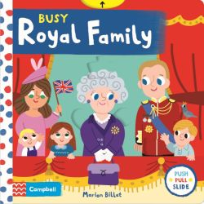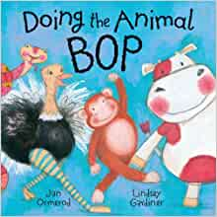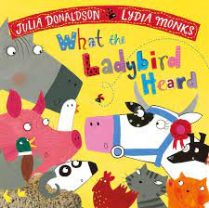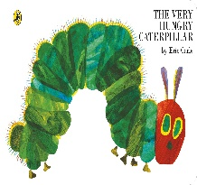iufiyfiyf

Let’s find out about Jungle animals!

Can you name an animal that lives in the jungle?

What’s it like in the jungle?

**Gross motor skills**

Children will be experimenting with different ways of moving, such as slithering, shuffling, rolling, crawling, walking, running, jumping, skipping, sliding and hopping.

Weekly PE sessions this half term will be on a Monday and it will be Gymnastics.

Let’s find out about Minibeasts!

What is an insect?

Can you name an insect?

Where would you find an insect?

Who is the Queen?

Why is she important?

Why are we celebrating her?

**‘All Creatures Great and Small’**

**Summer 1**

School value focus is ‘Protecting the environment’

Let’s find out about Farm animals!

Can you name an animal that lives on the farm?

Can we match animals to their babies?

**Fine motor skills**

Off to the Dough disco

Daily Funky Fingers

Finger gym challenge

**For any further information please do not hesitate to contact us on:**

Tel: 01827 213855

Email: [**office@twogates.staffs.sch.uk**](mailto:office@twogates.staffs.sch.uk)

Follow us on Twitter! @2gatesprimary

Nursery will participate in Forest School every **Friday afternoon**. Children will need to come dressed in their forest school kits (long sleeve tops, leggings or joggers, waterproof coat, wellies). We will go out for Forest school whatever the weather so it is important that children are dressed appropriately for the Great British weather!