iufiyfiyf

**Communication and language**

**Speaking**

Use sentences of four to six words.

Answer simple why questions?

Join in with repeated phrases in books.

**Physical development**

**Gross motor**

Continue to improve their spatial awareness.

Become independent in dressing themselves.

Children will participate in weekly P.E lessons on Monday’s. This half term we are learning about dance.

Nursery will participate in Forest School every **Friday afternoon**. Children will need to come dressed in their forest school kits (long sleeve tops, leggings or joggers, waterproof coat, wellies). We will go out for Forest school whatever the weather so it is important that children are dressed appropriately for the Great British weather!

**Personal, social and emotional development**

Continue to follows rules and expectations without reminding.

Selects and use resources and activities with support.

Plays in a group and can initiate play with others.

**For any further information please do not hesitate to contact us on:**

Tel: 01827 213855

Email: [**office@twogates.staffs.sch.uk**](mailto:office@twogates.staffs.sch.uk)

Follow us on Twitter! @2gatesprimary

**Letters and Sounds: Phase one**

Continue daily Read, Write, Inc sessions- learning pure sounds and how to blend them to make words.

Practise oral blending and segmenting such as *m-a-d* mad, s-a-d sad.

Identify initial sounds in words such as ‘c’ in cat.

**Communication and language**

**Listening and attention**

Continue to listen with interest and recall the events in a story.

Enjoy listening to stories and rhymes in daily rhyme time.

**Key texts:**

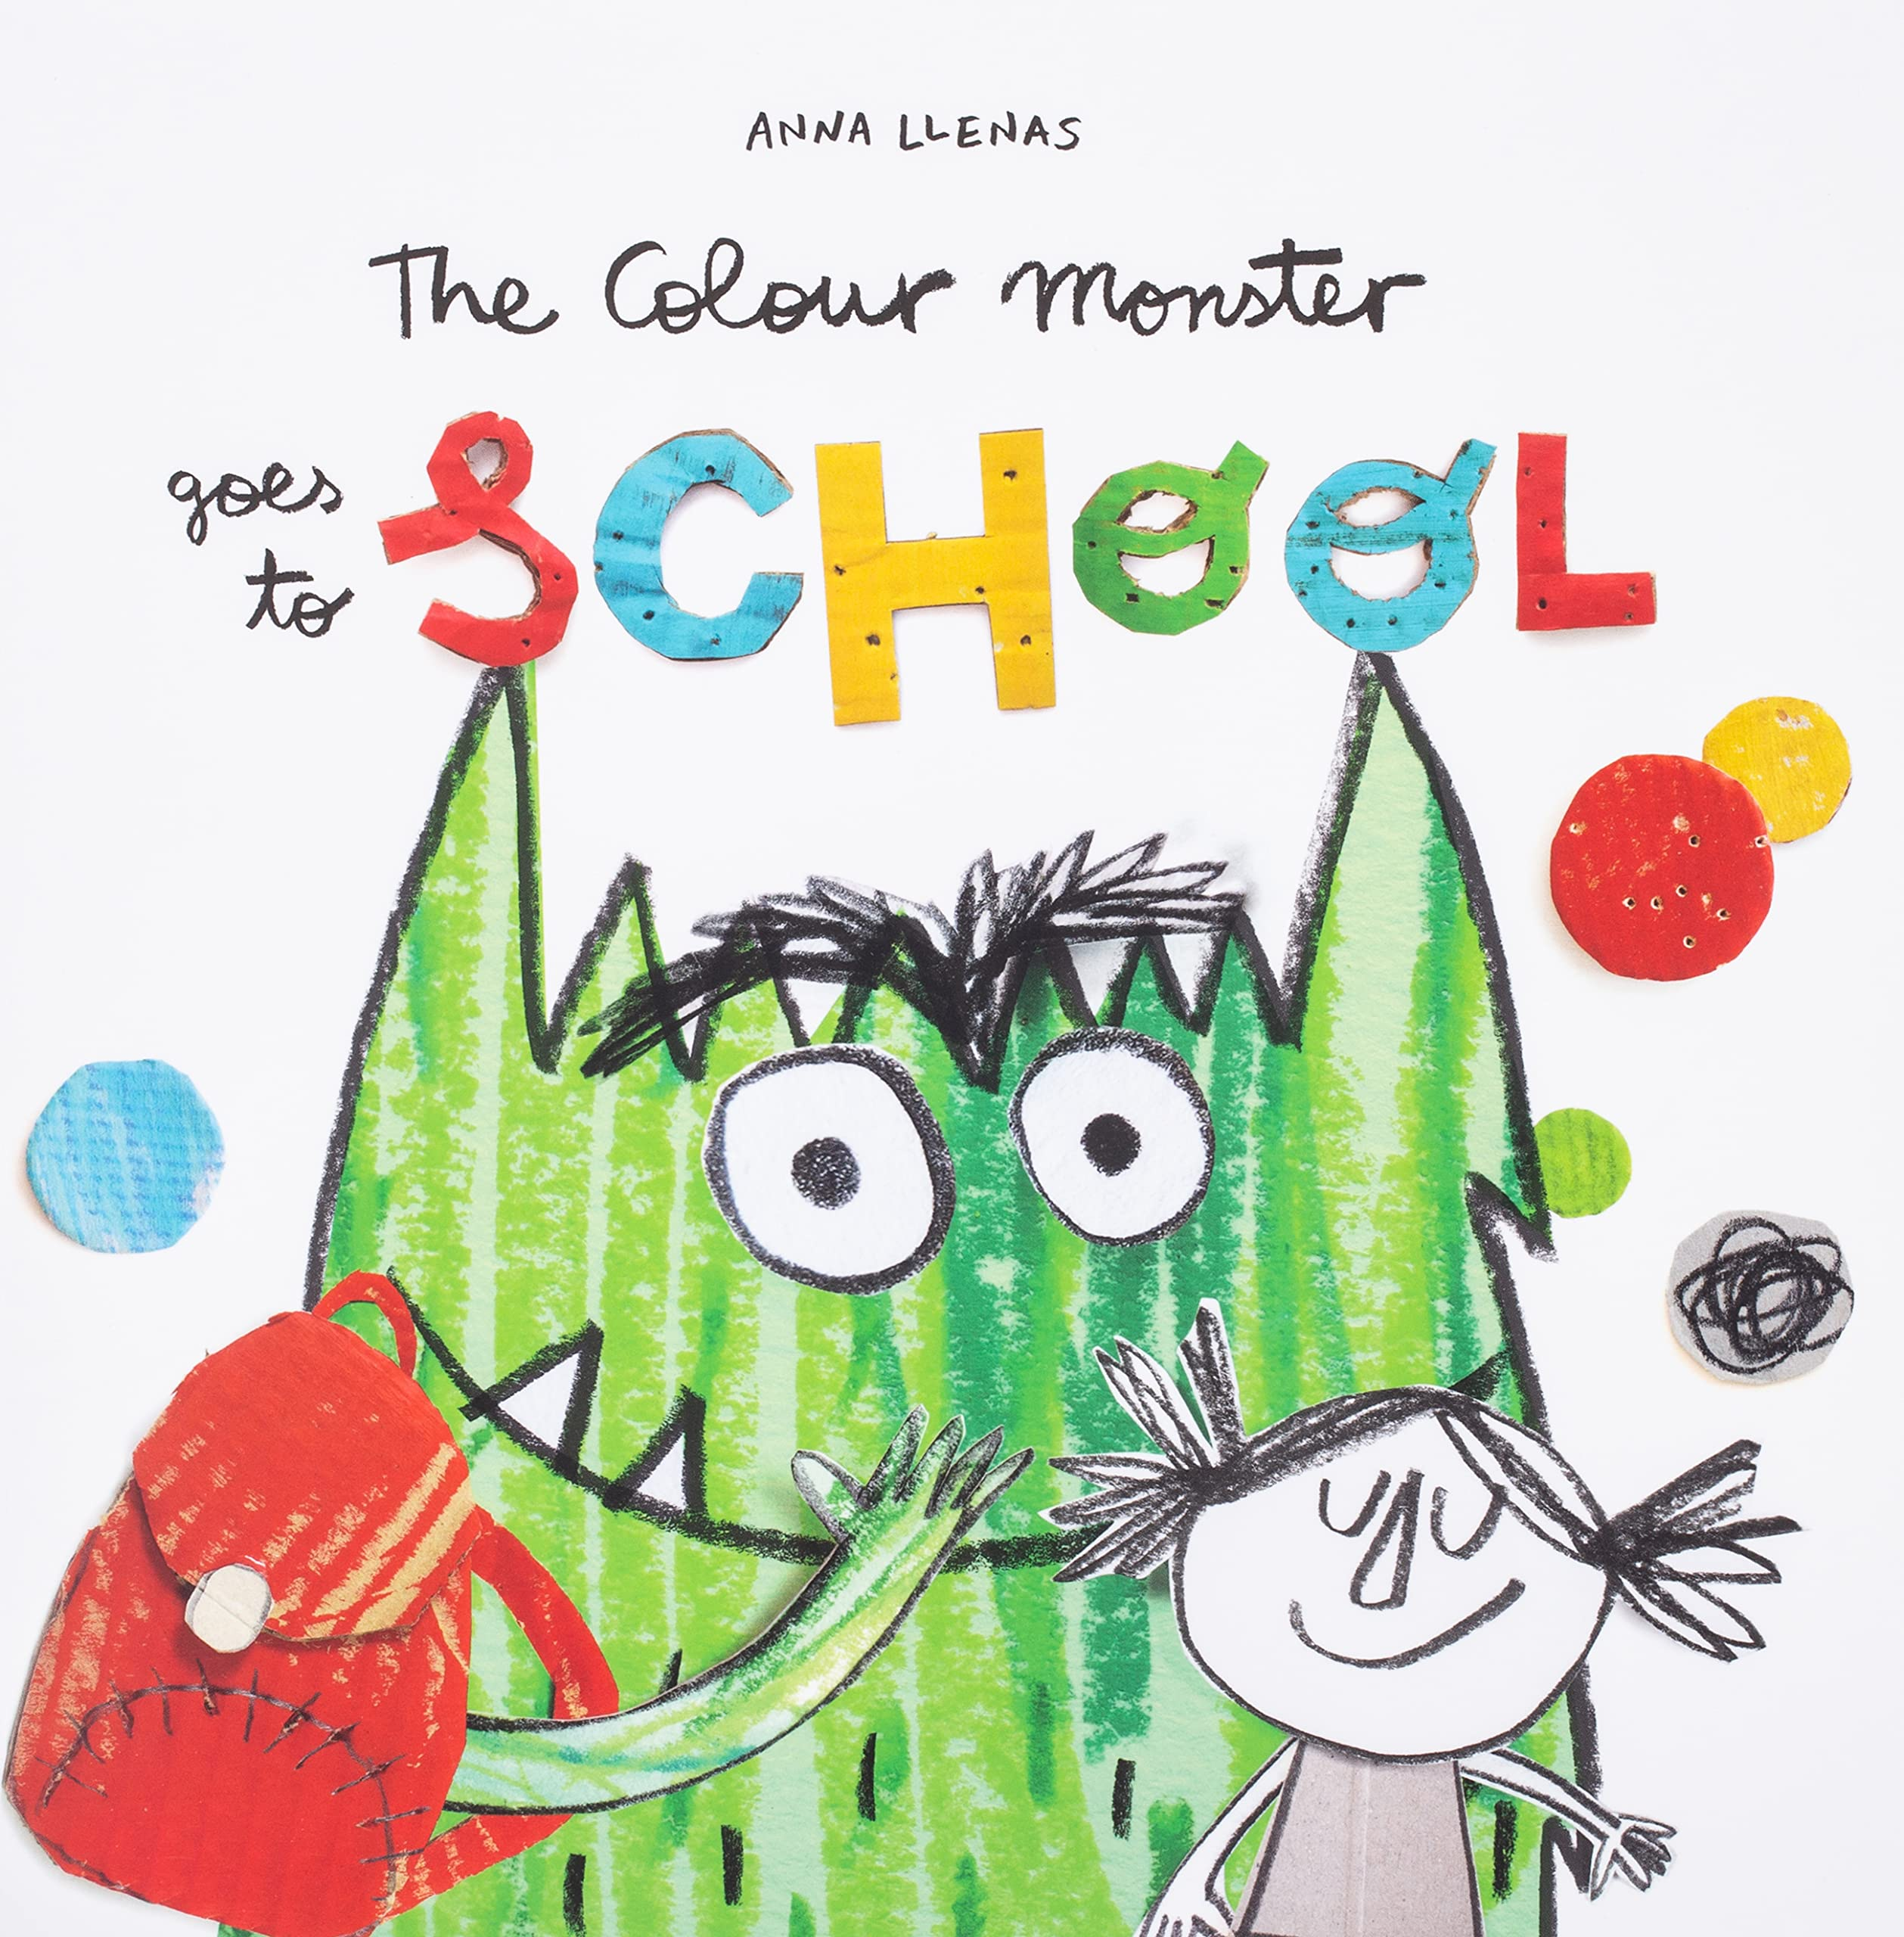 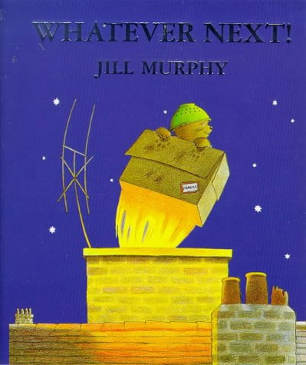

 ;’#’’

**‘We’re going on an Adventure’**

Nursery - Summer 2

School value focus is ‘Sense of belonging’

**Physical development**

**Fine motor**

Continue to accurately copy a cross, circle, horizontal and vertical straight lines and square from pre-writing shapes.

Daily funky fingers activities to help improve motor strength.