Appendix 1: Protecting Children from Significant Harm Booklet

Two Gates Primary School

Staff and Visitor Guidance September 2022
You must report any concern you have about a student’s welfare or safety to a DSL.
Safeguarding is everyone’s responsibility.

The identities of our DSLs in each school are displayed in prominent positions around the school, in reception and below.

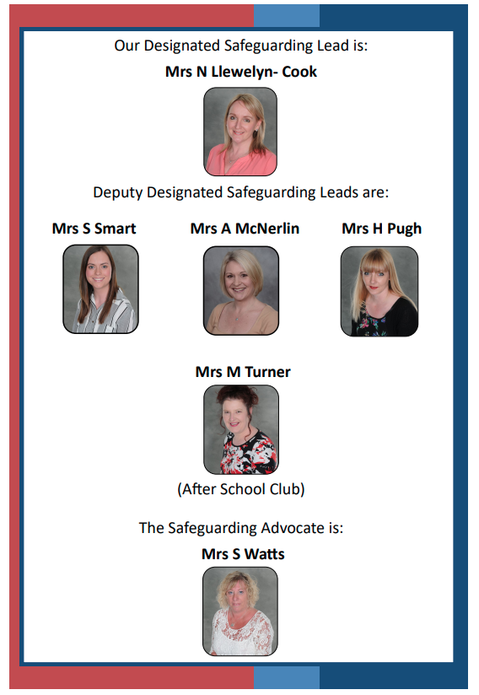

A DSL will always be available
A DSL may be accessed via School Reception

We recognise the importance of considering the context of each of our school to fully assess and reduce the risks to our students. As such, we are aware of the risks presented to our children by the local environment.
We know that extra familial harms take on a variety of different forms and children can be vulnerable to multiple harms including child on child abuse, sexual and criminal exploitation and serious violent crime and online abuse. Children may suffer abuse within the school setting or outside of school.
Two Gates Primary School is located close to the centre of Tamworth, Staffordshire. Known risks in the community include in addition to those above:
- higher rates than nationally of reported domestic violence
- higher than national deprivation rates including overcrowded housing
- the rail and motorway connections and proximity to Birmingham increasing the risk of county lines activity-child exploitation
- families experiencing financial difficulties
- extremist views relating to Far Right ideology.

My Concern has highlighted the categories of wellbeing, home issues, mental health and substance misuse. We work effectively and have strong relationships with our families and external agencies to try to prevent safeguarding issues escalating in our school and in our local community; we take rapid and appropriate action when necessary to protect our pupils and families. Our Early Help strategy and support is timely and focused on best outcomes and de-escalation of issues through collaborative working with families, involving external specialist support as necessary.

What is Safeguarding?
Remember Child Protection is everyone’s responsibility regardless of role or status.

Section 11 of the Children Act 2004 places duty on agencies to ensure that their functions are discharged having regard to the need to safeguard children and promote their welfare; by safeguarding and promoting welfare we mean:
- Protecting children from abuse or neglect.
- Preventing impairment of the children’s mental and physical health or development.
- Ensuring that children are growing up in circumstances consistent with the provision of safe and effective care; and
- Creating opportunities to enable children to have optimum life chances in adulthood
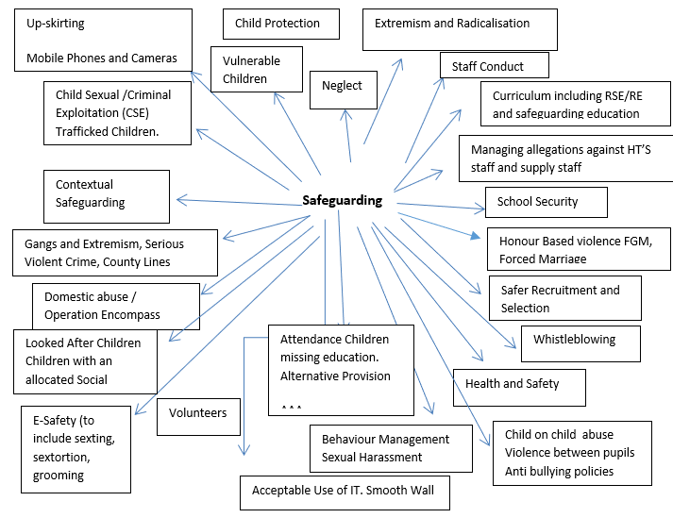
Child Protection is the responsibility of everyone. Report concerns to the right person, in person. For additional information please see policies and information on the school or The Staffordshire Safeguarding Children Board website or in Keeping Children Safe in Education 2022.
Child protection is just one aspect of safeguarding, one that we as a Partnership take very seriously.
It is much better to share a concern and be wrong than not share at all.

Remember there are many forms of abuse including extra familial abuse and intra familial abuse. We must be alert to them all. We must imagine the unimaginable. It could, and does, happen here!

Safeguarding and promoting the welfare of children is everyone’s responsibility.

If you have any concerns about the welfare or safety of a child in our care, you must share it.

You must use the system in your school to
- Refer immediately
- Inform the right person in person
- Do not email or leave a voicemail
- Record the date, time and details of discussions
- Keep copies
- In the first instance it is best to share your concerns with the DSL of the school that the child attends. In the unlikely event that they are unavailable, then report this to the head teacher or Leadership group member In an emergency phone the Police or contact Children’s Social Services directly.
Determining need – questions to ask yourself.

- Is this family coping?
- Is the child’s need being met?
- Have I ensured that the child has had an opportunity to speak, be heard and listened to?
- What are the relevant factors at the core of the child’s needs? Do I have a picture of the family as a whole, their parental capability and environment factors?
- Have I used this guide to prompt me to think more clearly and understand the situation?
- Have I considered any previous history of support, service involvement and the current risk and protective factors within the family? Think about what the child’s experience really is?
- Am I sure about my understanding of the information? If not, take advice in the first instance from a DSL?
- Have I discussed my analysis of the identified need with other professional involved with the child to achieve a more holistic approach?
- Have I discussed my concerns with the child and their family and offered advice and support?
- Have I asked the parents for written consent to my involvement, my assessment and/or referral and to information sharing to help engage services quickly?
- Have I been professionally curious?
- Have I thought about the needs of any sibling?
- Have I considered the context of this concern?

Remember – always see things from the child’s point of view.
Types of Abuse
There are many types and forms of abuse. These include physical, emotional, sexual, and neglect. We also need to consider exploitation, online abuse, radicalisation and extremism, honour-based abuse, and CSE, CCE County Lines, serious violent youth crime and Modern-Day Slavery, child on child abuse including sexual violence and harassment and other forms of exploitation. We also recognise the links between vulnerability, including poor mental health and abuse.
We also recognise that mental health problems, can in some cases, be an indicator that a child has suffered or is at risk of suffering abuse. We are aware of the rise in mental health issues during the pandemic linked to an increase in anxiety depression and isolation.
We are also aware of the increased dangers of online abuse due to often increased and unsupervised internet access This includes child on child abuse and sexual abuse
We also recognise the adverse impact of domestic abuse on children. Further details can be found in Two Gates Primary School Safeguarding and Child Protection Policy
The following may be indications of abuse, but this is not designed as a check list. It must also be acknowledged that these indicators rarely stand alone and that a child may exhibit all or just a few of these

Indicators of Abuse

Signs of Physical Abuse | Signs of Emotional Abuse
- Unexplained injuries or burns particularly if they are recurrent.  - Improbable excuses given to explain injuries.  - Inconsistent account given to explain injuries.  - Refusal to discuss injuries.  - Untreated injuries.  - Admission of punishment which appears excessive.  - Bald patches.  - Withdrawal from physical contact.  - Arms and legs kept covered in hot weather.  - Fear of returning home.  - Fear of medical help.  - Self-destructive tendencies.  - Aggression towards others.  - Reluctance to change in public, participate in PE or attend residential trips.  - Missing from Education.  - Multiple bruises.  - Bite marks.  - Isolation from peers. | - Physical, mental and emotional developmental lags.  - Admission of punishment which appears excessive.  - Bullying others.  - Continual self-depreciation.  - Sudden speech disorders.  - Fear of new situations.  - Inappropriate emotional responses to painful situations.  - Neurotic behaviour (e.g., rocking, hair-twisting, thumb-sucking).  - Self-mutilation.  - Extremes of passivity or aggression.  - Drug/solvent abuse.  - Compulsive stealing, scavenging.  - Tendency to cling or need constant reassurance.  - Running away.  - Exposure to domestic abuse and violence.  - Appetite disorders, anorexia nervosa, bulimia, obesity.  - Soiling, enuresis.  - Missing from Education
Signs of Sexual Abuse  CSE is growing across our Partnership | Signs of Neglect  Remember Neglect is the most difficult type of abuse to evidence but features in over 60% of Serious Case Reviews.
- Sudden changes in behaviour or school performance  - Displays of affection in a sexual way inappropriate to age.  - Unexplained gifts of money/phones.  - Tendency to cling or need reassurance.  - Depression and withdrawal.  - Apparent secrecy.  - Wetting, day or night.  - Sleep disturbances or nightmares.  - Inability to concentrate/tiredness.  - Chronic illness, especially throat infections and venereal diseases.  - Anorexia or bulimia.  - Unexplained pregnancy.  - Fear of undressing., for sport.  - Phobias or panic attacks.  - Regression to younger behaviour, such as thumb-sucking, playing with discarded toys, acting like a baby.  - Complaints of genital itching or pain.  - Distrust of a familiar adult, or anxiety about being left with a relative, a babysitter or lodger.  - Knowledge not related to age.  Signs of FGM  - Unexplained absences or absences due to UTI infections  - Missing from education  - Going on holiday with female relatives to receive a special gift / sudden appearance of many gifts  - Talk of becoming a woman / growing up  - Problems with periods / excessive blood loss  - Talk of Sunni – being cut  - Family history of FGM  County Lines and Serious Violent Crime  County Lines is a term used to describe gangs and organised criminal networks involved in exporting illegal drugs. Exploitation is an integral part of the county lines offending model with children and vulnerable adults exploited to move and store drugs and money. Offenders will often use coercion, intimidation and violence to ensure the compliance of victims. Children can easily become trapped by this type of exploitation.  Signs of County Lines  - Having a relationship of concern with a controlling adult or young person.  - Entering and/or leaving vehicle drive by unknown adults.  - Possessing unexplained amounts of money, expensive clothes or other items.  - Frequenting areas known for risky activities.  - Being groomed or abused via mobile technology.  - Missing for periods of time – truancy.  - Having unexplained contact with hotels, taxi companies or fast-food outlets.  - Being found out of their usual area.  - Excessive receipt of texts or calls.  - Evidence of physical injury or assault.  - Significant changes in wellbeing.  - Carrying weapons.  - Isolated from peers/change in friendships.  - Self-harm/mental health issues. | - Constant hunger.  - Poor personal hygiene/dirty clothes.  - Constant tiredness.  - Poor state of clothing/lack of kit.  - Emaciation.  - Frequent lateness or non-attendance at school/not collected from school.  - Untreated medical problems.  - Destructive tendencies.  - Low self-esteem.  - Neurotic behaviour.  - Affluent neglect.  - Failure to develop.  - Home alone.  - Adolescent neglect.  - No social relationships.  - Running away.  - Compulsive stealing or scavenging.  - Stealing food/money.  - Scavenging.  - No provision for lunch.  - Missing from Education  Signs of Forced Marriage  - Missing from school  - Requests for extended holidays  - Talk of surprise wedding  - Family history of forced marriage  - Decline in academic performance.  - Parental reports of concern.  - Train tickets indicating a journey to another part of the country.  - History of committing offences, substance abuse, anti-social behaviour.  - Presenting as troubled  - New friendship groups  - Significant changes in routine and presentation

Indicators of Vulnerability to Radicalisation  Radicalisation refers to the process by which a person comes to support terrorism and other forms of extremism leading to terrorism. Students may become susceptible to radicalisation through a range of personal, social and environmental factors. It is vital school staff are alert to these indicators.  - Identity crisis – the student is distanced from their cultural religious heritage and experiences discomfort about their place in society.  - Personal crisis - this may involve experiencing family tensions, a sense of isolation, low self-esteem. Students may become disassociated from existing friendship groups and involved with new ones. They may be searching for answers to questions about identity, faith and belonging.  - Being in contact with extremist recruiters.  - Accessing extremist websites.  - Possessing extremist literature.  - Joining extremist organisations.  - Significant changes to behaviour  - Experiencing a high level of identity crisis of personal crisis.  - Significant changes to appearance, attitude or behaviour.  - Justifying the use of violence to solve societal issues  Cyber Bullying  - Includes name calling, unpleasant texts, emails via social media or mobile devices  - Incidents should be recorded in line with school policy and sanctioned under Two Gates Primary School Behaviour policy  - Seek advice if unsure or persistent | CSE occurs when an individual or group takes advantage of an imbalance of power to coerce, manipulate or deceive a child into a sexual activity or criminal activity  - Unexplained absence from school and home, especially overnight.  - Child is “missing”.  - Older boy/girlfriends and multiple boy/girlfriends.  - Dressing much older than they look. Excessive use of make-up, inappropriate dressing.  - Withdrawn, tired, depressed, isolated from friends.  - Lack of interest in school, family, previous friendship groups.  - Evasive and confused responses to questions concerning how they are or what they are doing.  - Having unexplained contact with hotels, taxi companies or fast-food outlets.  - Having a relationship with a controlling adult.  - Possessions, unexplained gifts, new possessions, phones, amounts of money, expensive clothes or other items  - Train/road trips to other parts of the country  Child on child abuse  Children can abuse other children in a variety of forms including physical, sexual and emotional abuse  Sexual violence and harassment can occur between two children of any age or sex. Staff should be aware that some groups are potentially more at-risk including girls, children with SEND and LBGT children  - Follow normal safeguarding procedures  - Consider ‘balance of power’  - Seek advice if unsure or persistent  For additional information on forms of abuse see Annex B of KCSIE 2022

Advice on Sexting
Sexting is the sharing of images, videos of text by children under the age of 18 that are of a sexual nature or are indecent (including pseudo images) and includes revenge porn. Children need to know that this maybe a criminal offence. Early Years settings should follow the guidance in EYFS re mobile phones and cameras.

Criminal or not? The balance is between natural curiosity/risk taking/exploring relationships and deliberate, harmful, spiteful and illegal. (See ‘Sexting in Schools and Colleges – Responding to Incidents to Safeguard Young People (UKCCIS2016))

How to deal with the incident

- Follow normal safeguarding procedures.
- Tell a DSL
- Only view images if authorised by the Headteacher; only search if conducted by a member of the same sex (female teacher to view girls’ phone, male teacher to view boys’ phone)
- Do not download or ask for image to be sent, nor should you print any images
- Always seek advice and guidance

Children with a Disability

When working with children with disabilities, practitioners need to be aware that additional possible indicators of abuse and / or neglect may also include:

• A bruise in a site that might not be of concern on an ambulant child such as the shin, might be of concern on a non-mobile child
• Not getting enough help with feeding leading to malnourishment
• Poor toileting arrangements
• Lack of stimulation
• Unjustified and / or excessive use of restraint
• Rough handling, extreme behaviour modification e.g., deprivation of medication, food or clothing, disabling wheelchair batteries
• Unwillingness to try to learn a child’s means of communication
• Ill-fitting equipment e.g., callipers, sleep boards, inappropriate splinting
• Misappropriation of a child’s finances
• Inappropriate invasive procedures.

It is also worth noting that children with additional needs may be more vulnerable to abuse. This may include disabled children, as mentioned above, as well as those with special educational needs, those with health concerns including mental health, those recently bereaved, homeless and those living with domestic violence or drug/alcohol abusing parents or in poverty.

Responses from parents
Research and experience indicate that the following responses from parents may suggest a cause for concern across all four categories:
• Failure to engage or attend appointments
• Delay in seeking treatment that is obviously needed
• Unawareness or denial of any injury, pain or loss of function (for example, a fractured limb)
• Incompatible or inconsistent explanations offered, several different explanations or the child is said to have acted in a way that is inappropriate to her / his age and development
• Reluctance to give information or failure to mention other known relevant injuries
• Frequent presentation of minor injuries
• A persistently negative attitude towards the child
• Unrealistic expectations or constant complaints about the child
• Alcohol misuse or other drug / substance misuse
• Parents request removal of the child from home
• Violence between adults in the household.

Confidentiality
- Confidentiality cannot be promised to the child. This should be made clear to the child early on in any disclosure.
- Information should be shared with a designated person who will decide who else should know and what to do.
- Staff should be vigilant when sharing personal and confidential information. All confidential information should be shared on a “need to know” basis and via a secure mechanism. This is particularly relevant when sharing information electronically with a third party such as Social Services, NHS and CAMMS. If you are unsure, please seek guidance.
- Additional information and guidance can be found in The ATLP Green School GDPR Data Protection Policy.
How to Respond to a Disclosure
- Do listen carefully to what the child is saying
- Do take the child’s statement seriously
- Do write down as soon as you can exactly what the child said after the event
- Do not get the child to write it down or repeat it
- Do tell the child they are good to tell
- Do tell the child it is not their fault
- Do take care of yourself and work out how you are feeling
- Do ask open questions.
- Do not panic
- Do not rush off and find someone else to listen
- Do not promise to keep things secret
- Do not lie to the child or say everything will be fine now they have told someone
- Do not make judgements of any kind about the abuser especially if a parent
- Do not ask lots of detailed questions
- Do not press for answers a child is unwilling to give
- Do not ask leading questions.
- Record any injuries on a body map where appropriate
Allegations against Staff including low level concerns
The procedures laid out in The ATLP Allegations of abuse including low level concerns against staff Policy should be followed
- If an allegation is made against a member of staff, agency staff or volunteer, the member of staff receiving the allegation should immediately inform the Headteacher.
- They should not inform the subject of the allegation.
- Where a concern is raised, or an allegation has been made against a Headteacher/ Executive Team member or Chief Executive Officer, it must be reported immediately to the Director of Education/ Chief Executive Officer/ Chair of the Trust Board, as appropriate. If the allegation concerns a Trustee, then this should be reported to the Chair of the Trust
- They should not inform the subject of the allegation
- Advice should always be sought from HR
- Staff must report concerns including low level concerns to the Head teacher.
- Low level concerns are those that do not meet the threshold for referral to the LADO
- They include staff being over friendly with children, having favourites and taking photos of children

Safe Working Practices: Keeping Yourself Safe
Do you know what is expected of you in respect of?
- Mobile phone use:
Mobile phones should not be used during teaching time or for contact with students or parents. Do not share your personal mobile phone details with students or parents. Use a school phone. Follow the policy of the school in which you are working in relation to mobile phones
- Social networking and contact:
Ensure sites are set as private. Parents and students should not be listed as approved contacts. Don’t share personal details, post inappropriate comments. Don’t engage in activities outside school which might compromise your position in school.
- Physical contact:
Be wary of any physical contact that might be perceived as inappropriate. Don’t become over familiar.
- Students in distress:
Alert appropriate pastoral staff.
- Behaviour management:
Be aware of and follow school procedures closely.
- One-to-one situations:
Be open and overt in these situations. Notify a colleague. Select a room with a window, door open if possible. Be aware of personal space.
- Dress and appearance:
Promote a positive and professional appearance.
- Gifts
Received or given of any value, should be declared.
- Photography, video and creative arts:
Beware of parents who have withdrawn consent. Only use school equipment.
- Vigilance: Report any concerning behaviours of students and/or staff to a designated teacher. Ensure these are recorded.
- Transporting children in your car:
Check you have the right insurance. Always sit the child in the back seat. If possible, take another member of staff with you.
- Home visits:
Consult and follow the Home Visits Policy
- Staff should be mindful of Data Protection Regulations, particularly about sharing sensitive and personal information. For further details see The ATLP GDPR Data Protection Policy or consult your Data Protection Officer. The Data Protection Officer for Two Gates Primary School is please Mrs Michelle Render, Office Manager
- Staff should pay particular attention to The Acceptable Use of IT Policy and be aware of the current advice re remote working
- Remember all Two Gates Primary School devices are monitored via Smooth Wall

Key Messages
- Safeguarding and promoting the welfare of children is everyone’s responsibility regardless of role or responsibility.
- Child abuse happens everywhere – Notice Things! Develop your ‘professional curiosity’. Imagine the unimaginable.
- If you have concerns about a child share the concern with the DSL.
- Do not rely on emails, memos or voicemail. Do not leave until the next day.
- Always consider the worst-case scenario.
- We have a responsibility to report, record, monitor and support.
- Know and follow the child protection procedures.
- There will never be a convenient time, but you must pass your concern on.
- If you are aware of FGM in 18-year-old or under, you must report this to the Police on 101 on the same day (Teachers only).
Key Principles
- Always see the child first, listen to the voice of the child.
- Never do nothing.
- Do with, not to, others.
- Do simple things better.
- Have conversations, build relationships.
- Outcome not output.
Key Processes
All staff should be aware of the guidance issued by The Staffordshire Safeguarding Children Board and Two Gates Primary School Safeguarding and Child Protection Policy.
Copies are available from Reception
Staff should all have read and understood the latest copy “Keeping Children Safe in Education Part One and Annex B”.
Staffordshire (SCAS) 03001118007
NSPCC Helpline-0808 800 5000
All staff should receive safeguarding/child protection training annually. You must ensure that you access this. Staff should inform the school immediately if circumstances regarding their eligibility to work with children changes. Staff should also be aware of the information in KCSiE 2022 paragraph referring to a situation whereby an individual has behaved or may have behave in a way that indicates they may not be suitable to work with children. The reason is transferable risk.
All staff and volunteers should feel able to raise concerns about poor or unsafe practice in safeguarding. These in the first instance should be raised within school. Where a member of staff or volunteer feels unable to do this or they feel their concerns are not being addressed they should follow The ATLP Whistle Blowing Policy. The NSPCC Whistle Blowing helpline is also available as an alternative:
Monday to Friday 0200 028 0285 or email help@nspcc.org.uk

Report concerns to the right person and in person.
Remember: - Report, record, monitor, support.

